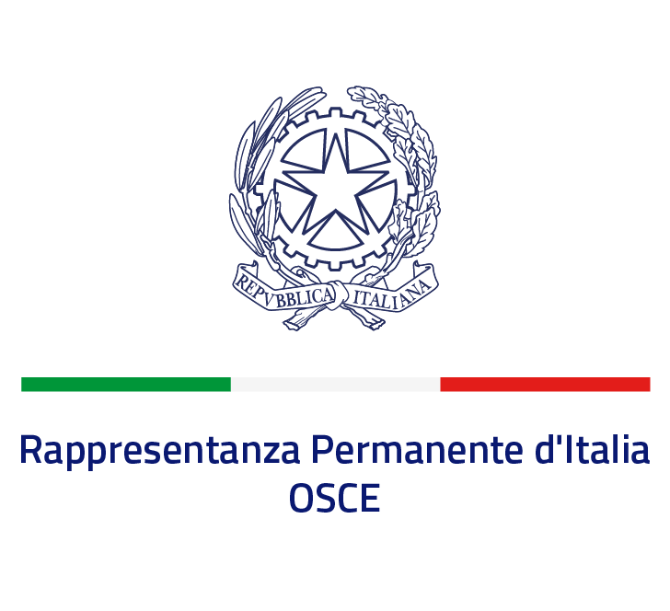  
Draft "OSCE LABORATORY" Program -

Seminar cycle in videoconference streaming 2022

**"The Organization for Security and Co-operation in Europe (OSCE)**

**as a model for multilateral regional diplomacy of the 21st century”**

***March - May 2022***

**(Total 20 hours)**

|  |  |  |  |
| --- | --- | --- | --- |
| ***Date*** | ***Time*** | ***Title*** | ***Speaker*** |
| **1.3.2022** | 17:30-18:30 | Introduction to the cycle | Stefano Baldi  (Permanent Representative of Italy to OSCE) |
|  | 18:30-19:30 | The Permanent Mission of Italy to the OSCE | Diplomatic Staff of the Mission |
|  |  |  |  |
| **8.3.2022** | 17:30-18:30 | The institutional architecture of the OSCE | Luca Fratini |
|  | 18:30-19:30 | *Case Study of Italian officials in OSCE* | *Italian OSCE officials* |
|  |  |  |  |
| **15.3.2022** | 17:30-18:30 | OSCE conflict management tools and procedures | Lamberto Zannier  (Former Secretaruy General OSCE) |
|  | 18:30-19:30 | *Case study: The OSCE activity in combating corruption* | *Prof. Pietro Pustorino, Prof. Raffaele Marchetti, Prof. Antonio Gullo (LUISS Guido Carli)* |
|  |  |  |  |
| **22.3.2022** | 17:30-18:30 | The OSCE Office for Democratic Institutions and Human Rights (ODIHR) | Matteo Mecacci  (Director ODIHR) |
|  | 18:30-19:30 | *Simulation: Request for an Electoral Observation Mission* | *Prof. A. De Guttry*  *(Scuola Superiore Sant’Anna di Pisa)* |
|  |  |  |  |
| **29.3.2022** | 17:30-18:30 | The fight against transnational threats | Denis Mazzolani |
|  | 18:30-19:30 | *Case study: Negotiations on the 2018 Ministerial Decision on preventing and combating violence against women* | *Prof. Cristiana Carletti, Dott.ssa Maria Alcidi (Roma Tre)* |
|  |  |  |  |
| **5.4.2022** | 17:30-18:30 | The OSCE Parliamentary Assembly | Roberto Montella |
|  | 18:30-19:30 | *Case Study of an OSCE Field Mission: the OSCE Presence in Albania* | *Vincenzo Del Monaco* |
|  |  |  |  |
| **26.4.2022** | 17:30-18:30 | The OSCE Mediterranean partnership | Emiliano Alessandri |
|  | 18:30-19:30 | *Case study: The OSCE Mediterranean Partnership and the Tunisian transition* | *Dott. A. Dessì*  *(Istituto Affari Internazionali)* |
|  |  |  |  |
| **3.5.2022** | 17:30-18:30 | The Second Dimension of the OSCE: Economic and Environmental activities | Lorenzo Rilasciati |
|  | 18:30-19:30 | *Case Study: The Italian Chairpersonship of the OSCE in 2018* | *Alessandro Azzoni*  *(Former Permanent Representative of Italy to OSCE)* |
|  |  |  |  |
| **10.5.2022** | 17:30-18:30 | Opportunities in the OSCE for young people | Mario Bartoli |
|  | 18:30-19:30 | *Case study: The challenge of communication in the OSCE: Narrative and/or Counternarrative?* | *Stefano Baldi*  (Permanent Representative of Italy to OSCE) |
|  |  |  |  |
| **17.5.2022** | 17:30-19:30 | *Concluding Round Table - The OSCE of tomorrow* | *All speakers* |

**Characteristics of the OSCE Laboratory**

**A) Educational objectives**

With a pragmatic approach, the workshop aims to foster a better comprehension of certain aspects and tools of multilateral diplomacy, in relation to the work of the Organization for Security and Cooperation in Europe. The final goal is to promote and develop participants' critical capacities through the analysis of concrete and current issues affecting the OSCE area.

At the end of the workshop, students should have acquired the necessary knowledge and instruments to enable them to:

- recognize and understand the main features of regional multilateral diplomacy, in particular in the OSCE context;

- evaluate and analyze the different instruments and strategies approaches as envisaged and implemented within the OSCE;

- identify and assess the OSCE strengths and shortcomings in the domain of international relations and regional geopolitics.

**B) Prerequisites**

The seminar cycle is offered to students who are currently enrolled in a bachelor degree or in a master course.

**C) Program**

The workshop is structured in a series of seminars, focused on the OSCE institutions, their functioning and on the main activities of the Organization. The seminars are complemented by a series of Case studies and Simulations related to specific activities. The seminars, which takes place in an online format, will be held by Ambassadors, Officers and Experts while University Professors and practitioners will run the “case Studies” and simulations.

**D) Educational methods**

The workshop is divided into 10 sessions of 2 hours each (*1h of lecture and 1h of case study - in both cases including Q&A*) and is based on an interactive teaching approach. All seminars will be in English.

Each Session will be held on an online platform (ZOOM). No Recordings will be available.

**E) Reference texts**

Due to the format of the seminars and the mandatory attendance required, the texts and all the materials on the topics of the workshop will be provided during the course.

**F) Formative credits**

Each university, according to their internal regulation, establishes the rules for participation to the seminars (e.g. by recognizing 2/more formative credits to the students who attend the workshop). For this purpose, the attendance for the whole seminar cycle shall be compulsory.

**G) Incentives**

Possible ideas to encourage the active participation of the students in the workshop:

1) Prepare students in advance, making sure that they have basic knowledge on the topics (also encouraging them to prepare some questions for the speakers). Some suggested material for reading could be provided beforehand;

2) A limited number of participants (3?) could be selected at the end of the seminar for internships at one of the research centers which are part of the initiative (e.g. through the submission of a research paper on one of the topics of discussion/ or a case study/ or a critical summary on the workshop).